BIO

_________________________________________________________________________
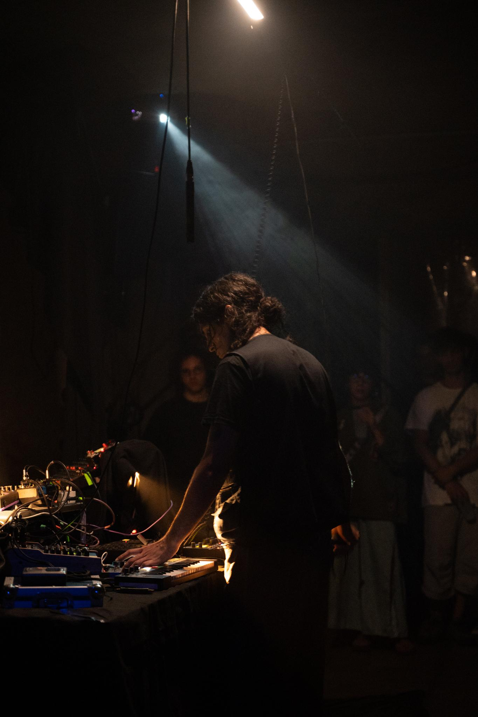

Omar Cheikh (IT-TN), 1996 works with sound and drawing.
He has collaborated with various independent labels and projects such as Maple Death, Lente Fantasma, Box of Tangerine, Futuro Arcaico, NoGlucose, Tocca il futuro, Erratic Boulders, Wetware Echo, and more, taking part in both V/A and creating mixes for radio stations such as LyLRadio, Tirkultura, Radio Raheem, and radio.syg.ma.
He is part of the independent space Titivil, based in Bologna.

Pic By Anna Righi
_________________________________________________________________________

